Q1:
class Address{
String state,city,street;
int zipCode;
public Address(String state, String city, String street, int zipCode) {
this.state = state;
this.city = city;
this.street = street;
this.zipCode = zipCode;
}
}
class Employee{
String firstName,lastName;
Address a;
boolean isValid = false;
public Employee(String firstName, String lastName, Address address1) {
this.firstName = firstName;
this.lastName = lastName;
this.a = address1;
}
boolean print_out(Address a1){
System.out.println("Full Name: " + firstName + " " + lastName + " Address: " + a1.street + " " + a1.city + " " + a1.state + " " + a1.zipCode);
if (a1.zipCode >= 10000 && a1.zipCode < 99999){
System.out.println("Zipcode is Valid.");
return isValid=true;
}
return isValid;
}
}
public class Q1 {
public static void main(String[] args) {
Address addr1 = new Address("Chase plus","Jamshoro","elm street",68923);
Employee e1 = new Employee("Aarib","YD",addr1);
e1.print_out(addr1);
}
}
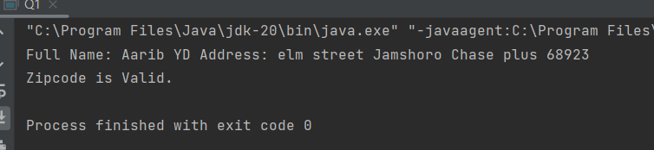

Q2:
class Room{
String roomType,roomSize,roomTemp;
public Room(String roomType, String roomSize, String roomTemp) {
this.roomType = roomType;
this.roomSize = roomSize;
this.roomTemp = roomTemp;
}
public String getRoomType() {
return roomType;
}
public void setRoomType(String roomType) {
this.roomType = roomType;
}
public String getRoomSize() {
return roomSize;
}
public void setRoomSize(String roomSize) {
this.roomSize = roomSize;
}
public String getRoomTemp() {
return roomTemp;
}
public void setRoomTemp(String roomTemp) {
this.roomTemp = roomTemp;
}
}
class House{
String room;
public String getRoom() {
return room;
}
public House(Room room1) {
this.room = room1.roomType + " " + room1.roomSize + " " + room1.roomTemp;
}
void Display(Room r1){
System.out.println("House Details: " +room + "\n");
System.out.println("Room details: " + r1.getRoomType()+ " " + r1.getRoomSize()+ " " + r1.getRoomTemp());
}
}
public class Q2 {
public static void main(String[] args) {
Room r1 = new Room("Suite" , "King", "25C");
House hs1 = new House(r1);
hs1.Display(r1);
}
}
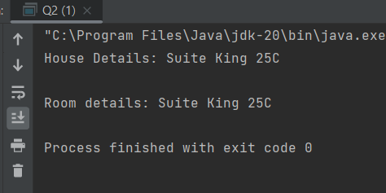

Q3:
import java.util.ArrayList;
import java.util.Collections;
import java.util.Comparator;
import java.util.Scanner;
class ShoppingCart{
ArrayList<String> itemList;
ShoppingCart(){
itemList = new ArrayList<String>();
}
void addItem(String item){
itemList.add(item);
}
void printItems( String item1, String item2) {
class ItemSorter implements Comparator<String> {
@Override
public int compare(String item1, String item2) {
return item1.compareToIgnoreCase(item2);
}
}
// Sort items using ItemSorter class
Collections.sort(itemList, new ItemSorter());
// Print items
for (String item : itemList) {
System.out.println(item);
}
}
}
public class Q3 {
public static void main(String[] args) {
ShoppingCart sc1 = new ShoppingCart();
Scanner scanner = new Scanner(System.in);
String item1 = scanner.next();
String item2 = scanner.next();
sc1.addItem(item1);
sc1.addItem(item2);
sc1.printItems(item1,item2);
}
}
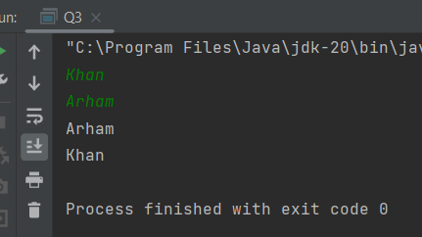
Q4:
class Vehicle {
private String name;
private int engineCC;
private String model;
public Vehicle(String name, int engineCC, String model) {
this.name = name;
this.engineCC = engineCC;
this.model = model;
}
public void display() {
class Owner {
private String name;
private String cnic;
private String phoneNumber;
public Owner(String name, String cnic, String phoneNumber) {
this.name = name;
this.cnic = cnic;
this.phoneNumber = phoneNumber;
}
public String getName() {
return name;
}
public void setName(String name) {
this.name = name;
}
public String getCnic() {
return cnic;
}
public void setCnic(String cnic) {
this.cnic = cnic;
}
public String getPhoneNumber() {
return phoneNumber;
}
public void setPhoneNumber(String phoneNumber) {
this.phoneNumber = phoneNumber;
}
}
Owner owner = new Owner("John Doe", "12345-67890-1", "123-456-7890");
System.out.println("Vehicle Name: " + name);
System.out.println("Engine CC: " + engineCC);
System.out.println("Model: " + model);
System.out.println("Owner Name: " + owner.getName());
System.out.println("Owner CNIC: " + owner.getCnic());
}
public static void main(String[] args) {
Vehicle car = new Vehicle("Toyota Corolla", 1300, "2019") {
@Override
public void display() {
super.display();
System.out.println("Owner Phone Number: 123-456-7890");
}
};
car.display();
}
}
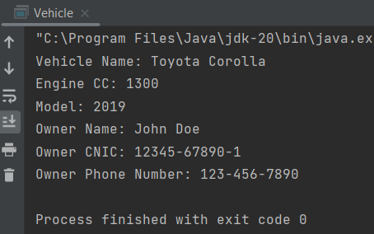

Q5:
class Car {
private String carname;
private String cartype;
public Car(String carname, String cartype) {
this.carname = carname;
this.cartype = cartype;
}
private String getCarname() {
return carname;
}
public class Engine {
private String engineType;
public void setEngine() {
if (cartype.equals("4T")) {
if (carname.equals("Mehran")) {
engineType = "Small";
} else {
engineType = "Large";
}
} else {
engineType = "Bigger";
}
}
public String getEngineType() {
return engineType;
}
}
public static void main(String[] args) {
Car car1 = new Car("Mehran", "4T");
Engine engine1 = car1.new Engine();
engine1.setEngine();
System.out.println("Car Name: " + car1.getCarname());
System.out.println("Car Type: " + car1.cartype);
System.out.println("Engine Type: " + engine1.getEngineType());
Car car2 = new Car("Civic", "2T");
Engine engine2 = car2.new Engine();
engine2.setEngine();
System.out.println("Car Name: " + car2.getCarname());
System.out.println("Car Type: " + car2.cartype);
System.out.println("Engine Type: " + engine2.getEngineType());
}
}

